**3.4** **I can test solutions to check that they work as intended**

|  |  |  |  |  |
| --- | --- | --- | --- | --- |
| Number | Description | Expected Outcome | Actual Outcome | Action to Take |
| 1 | Copying and pasting a website link to send others to a website | When clicking on the link the browser will open the linked to page | Page does not open in the browser | Check the entire pathway of the link has been copied correctly and modify if necessary |
| 2 | Pressing cntrl and S to save a document | The document is saved | The document is saved | No action required |
| 3 | Entering new HTML into style sheet | Once webpage is reloaded HTML creates the formatting required for website | Html does not create formatting required | Check for errors in HTML e.g. is a closing tag missing update HTML |
| 4 | Typing text into document | Text is spelt correctly | There are spelling mistakes | Proof read text and use spell check to identify any misspelt words |
| 5 | Open website in chosen web browser | Website opens in browser | Website opens with reduced functionality and formatting | Choose different web browser |
| 6 | Editing an office document | Document can be edited and saved | Document is read only and cannot be edited until saved | Save the document in own folders and then edit |

**Example images:**

Text is entered into word but a word is spelled incorrectly and highlighted as an error by spelling and grammar tool;

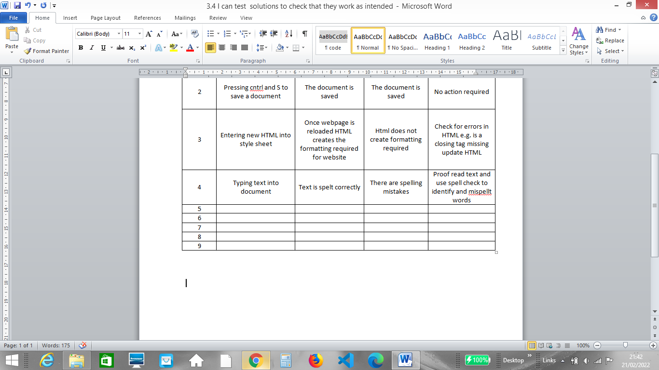

Spelling and Grammar tool suggests correct spelling and spelling is corrected;

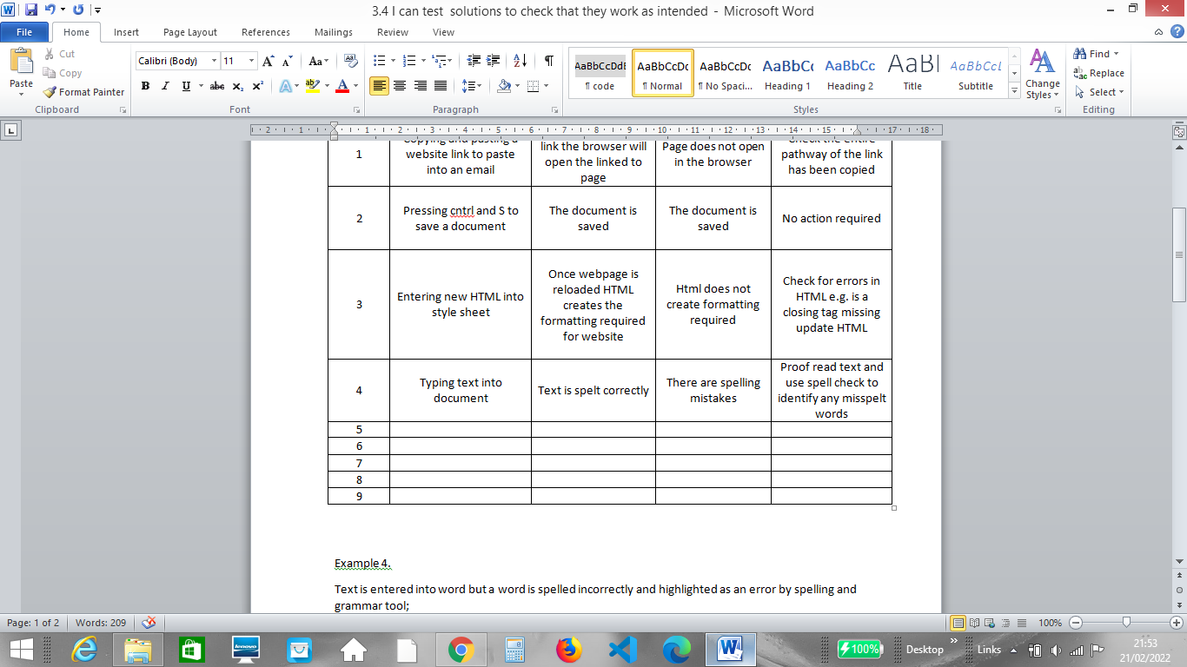

Link to an incorrect URL is given and leads the web user to the incorrect webpage;

E.g. <https://github.com/rach1533/Unit-One/settings/pages/123675>

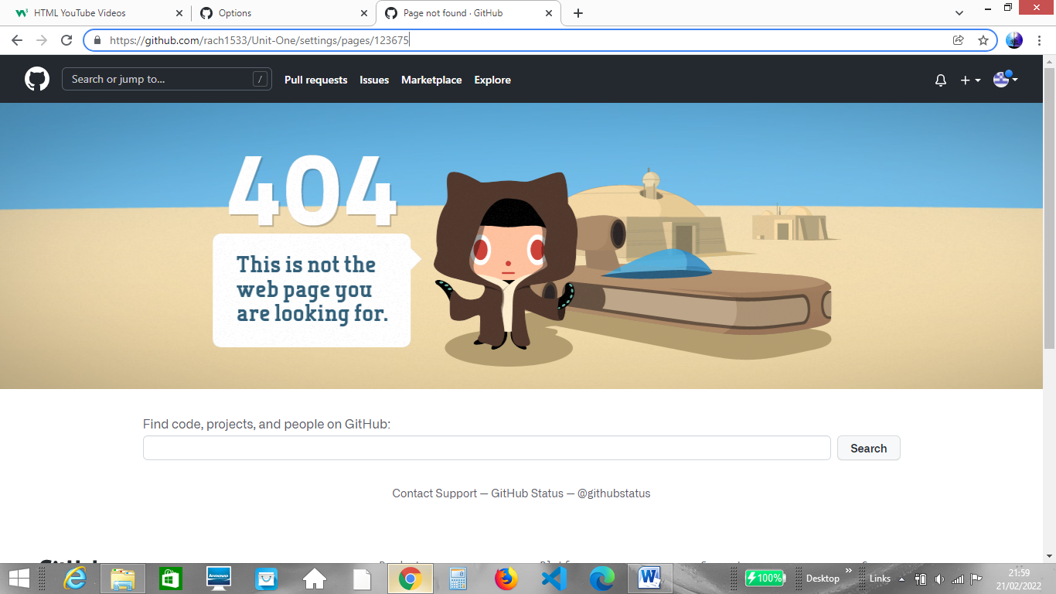

URL is double checked and resent to user leading to the correct web page;

